PROGRAM 1:

p1

PROGRAM 2:

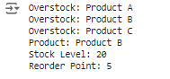

PROGRAM 4:

